# Decomposition Analysis of Index of Multiple Deprivation (IMD) Based on Shapley Value

Candidate: Xiaohan Feng

Submission Date: 25/08/2020

Module Name: MSc Dissertation

Module ID: CASA0004

Supervisor: Prof. Huanfa Chen

Word Count: 10359

This dissertation is submitted in part requirement for the MSc in the Centre

for Advanced Spatial Analysis, Bartlett Faculty of the Build Environment, UCL.

**Abstract**

Many government programs consider IMD a reliable technique to quantify the geographical variation of deprivation and use it as a guidance to allocate resources. However, the subjectivity of the settings of the calculation process and the intrinsic flaw of the data may cause bias of the final IMD. Additionally, IMD is derived from the composition of seven domain scores. It allocates the fixed weight from the seven domains for each LSOA area and this may induce us to think that the importance of the seven fields is in the same pattern among all these areas. However, our study found that the contributions of seven deprivation domain scores to the IMDs in England varies in LSOAs. It is clearer after we do the clustering and divide the similar small areas into 4 clusters. Most of the wards is deprived in housing and service domain and live environment domain. To cope with it, it is urgent to build more affordable housing with suitable living environment. In addition, the integration of the housing and services programs is a good way for elderly people who are in bad health. As for the deprived rural areas, almost all domains, except for the House Domain, are very serious. The basic idea to improve the situation in these areas is to develop the economy. And as a cycle, in order to develop the economy, we need to improve the other domains, especially the Education Domain and the Unemployment Domain.

Key words: IMD, geographical variation, Shapley value

**Declaration of Authorship**

I, Xiaohan Feng, declare that this dissertation is entirely my own original work

and that all sources have been acknowledged. This dissertation is 10,359words in length.

Signed: Xiaohan Feng

Date: 25/8/2021

Contents

1. Introduction 3

2. Research question 3

3. Literature Review 4

3.1. IMD 4

3.1.1. The definition of IMD 4

3.1.2. The function of IMD 4

3.1.3. The limitation of IMD 4

3.2. Shapley Value 6

3.2.1. Shapley Value in geography / GIS / urban research 7

4. Methodology 8

4.1. Shapley Value 8

4.2. SHAP(SHapley Additive exPlanations) and KernelSHAP 9

4.2.1. KernelSHAP 10

4.3. K-Mean Clustering 11

4.3.1. K-Means Algorithm: Expectation–Maximization 12

4.3.2. Selection for K 12

5. Experiment and Result 13

5.1. Data presentation 13

5.2. Data preprocessing 13

5.3. Result 14

5.3.1. Shapley value result 14

5.3.2. Clustering analysis 18

6. Discussion 26

7. Conclusion and Limitation 30

8. Reference 30

**Acknowledgements**

Firstly, I would like to thank my supervisor Dr huanfa Chen for her enthusiasm, guidance and feedback throughout this research. Your enthusiasm is infectious and inspired me to rise to the challenge.

## Introduction

Many government programs consider IMD a reliable technique to quantify the geographical variation of deprivation and use it as a guidance to allocate resources. The Oxford University team pointed out that about 1% of all government spending refers to the IMD (OCSI, 2011). Thus, it’s necessary to have a cautious and precise inspect into the mechanism of IMD. Additionally, IMD is derived from the composition of seven domain scores. It allocates the fixed weight from the seven domains for each LSOA area and this may induce us to think that the importance of the seven fields is in the same pattern among all these areas (like the income deprivation would always plays 22.5% of the importance of the overall deprivation in all small areas). However, just like the government needs different srategies to tackle the same set of problems according to each district’s local condition. The main contribution to deprivation in seven domains are also likely to vary in different areas. Moreover, knowing this variation is significant, because only realizing how deprived each area can only give the policymaker an idea about fund distributing among areas. Nevertheless, which domain are worth funding, how to better use the fund to improve the overall situation of a certain region would need the information from each domains.

But how can we get the exact contribution for each deprivation domain scores to the final IMD score given that the calculation is kind of complex (standardized the domain scores by ranking and then transforming to a specific exponential distribution based on their ranks)? Shapley value as an explanation method can help to handle it.

To sum up, this article aims to evaluate the contributions of the seven domains to the final deprivation of each area using shapley value and compare the difference over areas. After ascribing the effects to the specific seven domains, we can propose the targeted policies to different areas according to the deprivation of the specific domains.

## Research question

Are there variations of the contributions of seven deprivation domain scores to the Index of Multiple Deprivation (IMD) across LSOAs (Lower-layer Super Output Areas) in England?

What corresponding measurement could be taken for policymakers to alleviate the problem brought by the deprivation that derived mainly from different domains and improve the overall living circumstances in areas that have a high rank of IMD?

## Literature Review

### IMD

#### The definition of IMD

It is an interesting area to quantify the spatial variation of social and economic circumstances of different areas. One of the most famous attempts is the English government’s Index of Multiple Deprivation (IMD), which measures deprivation in England locally. IMD dissects deprivation to evaluate the social welfare. It is considered as a combination of seven social and economic aspects by the English government. Because of that, seven domain measurements of deprivation are developed, including Income Deprivation; Employment Deprivation; Education, Skills and Training Deprivation; Health Deprivation and Disability; Crime; Barriers to Housing and Services; Living Environment Deprivation. Each main domain has a bunch of sub-domains to integrate the concept (Ministry of Housing Communities and Local Government, 2019). Nowadays the main domains of IMD are similar across the world. For example, the IMD of New Zealand is also composed of seven domains that are similar to the composition of IMD in England (Exeter *et al.*, 2017). The IMD of German has five domains similar to the England. The additional special two are municipal revenue deprivation and social capital deprivation (Maier, 2017). In fact, the theoretical basis of determining deprivation is taken from Townsend’s work in the 1980s, in which he defined the deprivation as lacking “diet, clothing, housing, household facilities, and fuel and environmental, educational, working and social conditions, activities and facilities” (Noble *et al.*, (2006) quoting Townsend, p. 172). To sum up, IMD is the index which use the census and other government data to describe the situation of deprivation geographically.

#### The function of IMD

Since the data to calculate IMD are all authoritative data, it is widely accepted and used in many fields. Government can use IMD to help target resources to “priority areas”. In other words, it is a useful tool to guide resource distribution around the country. For example, it was ever used to help the central government of England to determine the eligible amount of Neighborhood Renewal Fund monies to the local authorities (Cabinet Office, 2001). And some government framework for regeneration and funds allocation documents made explicit references to IMD (DCLG, 2008;DCLG, 2009). IMD is also broadly used as a key indicator to identify the need or deprivation of local people within academic circles. Experts used it to propose more targeted policy suggestions or develop more realistic theorems (Bull and Jones, 2006; Kintrea, 2007; Macintyre, Macdonald and Ellaway, 2008).

#### The limitation of IMD

Given the fact that IMD is more and more widely employed in many fields, it is necessary to understand the limitation of it.

##### Limitation about multiple indexes

IMD is the combination of multiple domains, thus, it shows an overview of the local deprivation. However, on the other hand, it may also be difficult to eliminate the measurement error and aggregation irrationality of so many domains of data. And as an aggregated index, it suffers that “deficits in some sectors, which actually threaten the health of the whole system” (Bossel, 1999). No matter which indexes of domains or sub-domains are wrong, they will all affect the final effectiveness of the final IMD. The relationship of the sub-index inside IMD may also cause the problem of estimate the deprivation. For example, poor health may affect employment opportunities and income, which further affect the Barriers to Housing and Services Domain (Briggs, Abellan and Fecht, 2008). In other words, some domains cannot eliminate the influence from others. As a result, the combination of the domains, IMD, may pay more attention to some certain aspects of deprivation, which is wrong form the initial weight settings by the experts.

##### Limitation about subjectivity

What’s more, due to lots of subjective intervene, IMD always raises concerns about paternalism. For example, the allocation of weights to different domains, the choice of indicators in each domain, and many other mechanisms are all determined by the experts’ judgements (Watson *et al.*, 2019); the exponential transformation on the domains is done without explanation and implication (Deas *et al.*, 2003); the process to construct the multiple deprivations lacks the general theory support (Clelland and Hill, 2019). We cannot guarantee all these settings proposed by the experts are all suitable to current society, and it is always dilemmatic to judge the effectiveness of the subjective judgements of experts. Therefore, the validity of the results and the utility in the policy decisions may face challenges.

##### Limitation about data

Some of the individual indicators used in the computation of the local IMD were collected at a district or even national scale. Without using the exact ward data, the estimated values may distort the accuracy of the local IMD (Deas *et al.*, 2003). In addition, some indicators are double counted across more than one domain. Such as Severe Disablement Allowance contributes to not only the Employment Deprivation Domain but also the Health Deprivation and Disability Domain. Though some expert argued that it is legitimate to count the indicators as two deprivations (University of Oxford, 2000), it still raises concerns about the veracity especially when we do the overall factor analysis of all the indicators of IMD (Deas *et al.*, 2003). Besides, some indicators which are used to calculate the domain scores are based on census data years ago. It means they are not very recent data for the area and as a result, they cannot reflect the current circumstances and may cause measurement error.

##### Limitation about comparison

The IMD scores is only utilized to rank the deprivation among areas, but it is not a numeric measurement of the deprivation (OCSI, 2011). It cannot tell people how much one area is more deprived than the other, since the score has no quantitative meanings. In addition, we cannot compare the deprivation situation of one area over time. The IMD score of one area will change relative to other areas, thus it cannot tell us how much one area develops these years. The decrease of the score of one area may be due to the degeneration of its social and economic environment, but also may because of the fast development of other areas. Thus, we can only consider the deprivation as an order of the deprivation level among all the areas.

### Shapley Value

Shapley Value aims to figure out the reasonably expected payoff for each player in a cooperative game. One of the most famous problems solved by Shapley Value is the cost-sharing problem(Gul, 1989; Pérez-Castrillo and Wettstein, 2001; CHUN, HU and YEH, 2017). For example, Siano, Gallo and Glielmo (2015) calculated the distribution of costs of the shared travel for each driver and passenger, based on the application of the Shapley value. He presented a demand and supply managing algorithm for the shared transportation system, and thus the participants of the system are in a cooperative game, sharing the benefit from the transferable utility and superadditivity of the system. The Shapley value is used to calculate the marginal cost that each participant adds to the coalition system. Also in the transportation field, Lu *et al.* (2010) designed a urban railway ticket pricing mechanism by using Shapley Value. In his model, the government, Metro Corporation and passengers are the three participants of the cooperative game. By calculating the Shapley Value, the model can produce price adjustment advice in different service stages based on the expected profit distribution of the participants, which can ease the conflict of the participants’ different interest requirements.

Along with the development of Machine Learning models, Shapley Value is popular to be applied to helping understand the intrinsic influence factors of Machine Learning models (Lundberg and Lee, 2017; Lundberg, Erion and Lee, 2018), since Machine Learning models are always the “black box” which conceals the importance of the factors for us. Smith and Alvarez (2021) studied the mortality of patients with COVID19. He used Shapley Value to interpret the results of a series Machine Learning models, such as Naive Bayes, Logistic Regression, LightGBM, XGBoost and so on. By this method, he found that ages, days in hospital and some other factors are the robust predictors in the models. Besides, the Shapley Value can provide the marginal impact of each mortality factor on a case-by-case patient level, which is very helpful to detect anomalous patterns when treating patients.

Contributing back to the cooperative game theorems, Shapley Value is also widely used to discuss the time-consistent cases. Petrosjan and Zaccour (2003) studied the time-consistent Shapley Value to allocate the cost of pollution reduction for countries. It was proved that using the outcomes of Shapley Value, each country can receive a fair time-consistent cost and the total cost would be lower than the sum of the cost of each country assuming playing a noncooperative game. Reddy, Shevkoplyas and Zaccour (2013) also discussed time-consistent Shapley Value. Their theory decomposes the Shapley Value for dynamic stochastic discrete-time games over time. The Shapley Value results showed that their dynamic allocation method is time consistent and can be widely applied in many fields to help build a long-term cooperation relationship among players.

#### Shapley Value in geography / GIS / urban research

##### The regional policy suggestion of the CO2 emissions by Shapley value

Many experts in China using the Shapley Value decomposition method to analyze the key factors of CO2 emissions in different areas (Yu, Wei and Wang, 2014; Liang *et al.*, 2018). By this method, we can see more detailly about influenced factors of the CO2 emissions in geographic level. Li et al. (2016a) used the aggregate data from the World Input-Output Database to study the main drivers behind energy-related CO2 emission for agricultural sectors across eighteen European countries. By Index Decomposition Analysis (IDA) facilitated by the Shapley Index, he found decreasing energy intensity is the main way to decline the CO2 emission. Yan et al. (2018) used the same method as Li, and studied the provincial CO2 emissions from China’s thermal electricity generation. The Shapley Value results showed that economic activity is the main factor to push up the CO2 emissions in about 30 provincial power grids in China. Zhang, Wang and Dac (2014) compared the entropy and Shapley Value methods in allocation the carbon quota to different regions in China. He found the result of the entropy method has a positive effect on the task of the Shapley value method. From the final analysis results of Shapley Value, he came up with some targeted policy suggestions for the CO2 emissions reduction in China regionally. Wen and Hao (2020) combined the Shapley Value with Spectral Clustering algorithm to decompose the factors of CO2 emissions at the provincial level in China. He found carbon intensity played a significant role in most provinces, but there are other factors that affect the CO2 emissions differently in different provinces. Based on the PSO-FCM clustering method and Shapley Value, Yu, Wei and Wang (2014) clustered the 30 provinces of China into four classes according to 13 macro factors which may influence CO2 emissions. He proposed three-parts CO2 emissions reduction strategies to be suitably used at the provincial level. By Shapley Value, he also found the main approaches to reduce the CO2 emissions for each class, respectively. The Shapley Value decomposition method can give customized policy suggestions that vary from region to region in the light of local conditions.

##### Other fields using Shapley Value related to urban research

The Shapley value method is also used in many other fields to provide the intrinsic view about the influence factors on the certain problem. Chen and Li (2014) used Shapley Value to decompose the income inequality into five main aspects, including education disparity, household registration, geographic location, type of job, and gender. Geographic location plays the third important role in the analysis. The study paid extra attention to the geographic analysis, since the regional difference may affect other influence factors of income inequality. Aristondo and Onaindia (2020) applied the Shapley Value decomposition method to explore overall poverty change in terms of three poverty components’ changes. He found that the incidence, intensity, and inequality should all be taken into account as the poverty measures according to Shapley Value. He applied the theory to 28 European countries and got the regional analysis results for each country. Dong *et al.*, (2020) employed the regression-based Shapley decomposition method to aid the analysis of haze pollution by quantile regression. The population density of regional inequality is found by Shapley Value to be the most important factor of regional differences in haze pollution.

## Methodology

### Shapley Value

Shapley value is created by Shapley (1953) from cooperative game theory and aims to assign player’s payout according to their contribution. It is similar to other explanation methods in some cases. However, these methods are based on the certain assumption (take LIME for example, it assumes that the target black-box model can be locally approximated by some interpretable model like decision trees and linear models) and do not have the theory to support it; while Shapley value has the solid theory as it is the only method that satisfies the properties of a fair payout: Efficiency, Symmetry, Dummy, and Additivity (Molnar, 2021). Following is a detailed explanation of these properties.

##### Background

We assume there are total n people in collaboration and they create a profit of $v\left(N\right).$ What need to do is fairly distribute this profit.

$N=\{x_{1}, x_{2}…,x_{n}\}$ and $x_{i}$ is the vector of feature values of the instance (player $ⅈ$).

$S$ is a subset of the $N$. $v\left(S\right)$ represents the value generated by the cooperation of the elements in the S. The final Shapley value for player i is $ψ_{i}\left(N,v\right)$.

##### Properties

1. **Efficiency:** the full yield of the game is distributed to the players, which means the sum of the Shapley value among players equal to the total value. $\sum_{i∈N}{ψ_{i}\left(N,v\right)}=v(N)$
2. **Symmetry**: i and j are interchangeable relative to $v$ if the contributions of them are equal to all possible coalitions. For all $S$ that contains neither i nor j, if $v\left(S∪\left\{x_{i}\right\}\right)=v\left(S∪\left\{x_{j}\right\}\right)$, then $ψ_{i}\left(N,v\right)=ψ_{j}\left(N,v\right)$. That is to say, interchangeable (equivalent) players receive the same amount of payments.
3. **Dummy**: player i is dummy if his contribution to any coalition is zero. That would mean, $v\left(S∪\left\{x_{i}\right\}\right)=v(S)$. For all S, if i is dummy, he should have 0 Shapley value(receive nothing)， $ψ_{i}\left(N,v\right)=0$.
4. **Additivity**：if a game can be separated into two parts $v=v_{1}+v_{2}$, then the distributed gains from value function $v$ should correspond to the gains derived from $v_{1}$ and the gains derived from $v_{2}$. For every coalition S and player i, $ψ_{i}\left(N,v_{1}+v_{2}\right)=ψ_{i}\left(N,v_{1}\right)+ψ_{i}\left(N,v_{2}\right),$ where the game $\left(N,v_{1}+v_{2}\right)$ is defined by $\left(v_{1}+v_{2}\right)\left(S\right)=v_{1}\left(S\right)+v_{2}\left(S\right).$

This is a prime requisite if a researcher intends to design an evaluation scheme that would be applied to the “systems of interdependent games”(Kuhn, 1997).

The Shapley value is proved by Shapley (1953) to be the only map from the set of all games to payoff vectors that satisfies all four properties.

$$ψ_{i}\left(N,v\right)=\sum_{S⊆N\backslash \{x_{i}\}}{\frac{\left|s\right|!\left(|N|-\left|s\right|-1\right)!}{|N|!}\left(v\left(S∪\left\{x_{i}\right\}\right)-v\left(S\right)\right)} (1)$$

From the formula above, we can get that the Shapley value of a feature value is its average marginal contribution over all possible coalitions to the payout

### SHAP(SHapley Additive exPlanations) and KernelSHAP

If the model is simple, the best explanation model is itself; while if the original model is hard to understand, an explanation model, which always pertains to the class of “additive feature attribution methods” will be used to interpret it (Lundberg and Lee, 2017).

We assume the original model is f and the explanation model is g. Then, the model g which belongs to the “additive feature attribution methods” will satisfy the following formula:

$${g(z}^{'})=ϕ_{0}+\sum_{\dot{l}=1}^{M}{ϕ_{i}z_{i}^{'}} (2)$$ Where $z^{'}∈\{0, 1\}^{M}$, $ϕ_{i}∈R$ and M is the number of features.

SHAP was first proposed by Lundberg and Lee (2017) and its innovation is that it can represents Shapley value explanation as the above formula. In SHAP, $z^{'}$ would be considered as the coalition vector where an entry of 0 means the feature value it corresponds to is “absent” and an entry of 1 would be “present”. Thus, for x (the instance of interest), all the features are “playing” which means it is a vector of 1’s. In this case, the formula can be simplified as:

$${g(x}^{'})=ϕ_{0}+\sum_{\dot{l}=1}^{M}{ϕ_{i}} (3)$$

Since SHAP computes Shapley values, it also satisfies the four properties mentioned above. Besides, SHAP has three properties desired to get the single unique solution just like other models that belongs to the class of additive feature attribution methods.

##### Properties

1. **Local accuracy:** the output of the function f we are seeking to explain is equal to the sum of all feature attributions. It seems to be very similar to the “efficiency” property of Shapley value and actually can be derived from it.
$$f\left(x\right)=g\left(x^{'}\right)=ϕ_{0}+\sum_{i=1}^{M}{ϕ_{i}x_{i}^{'}} (4)$$

2. **Missingness:** a missing feature (such that $z_{i}^{'}$ = 0) attributed no importance. In theory, features that are already missing could have any arbitrary Shapley value and would not hurt other properties as it multiples by $z_{i}^{'}$ = 0.
$$z_{i}^{'}=0⇒ϕ_{i}=0$$

3. **Consistency:** changing a model so a feature has a larger or the same impact on the model, its Shapley value will also increases or keep constant. What’s more, this property is an indication of properties for Shapley: Linearity, Symmetry and Dummy.

For any two models $f$ and $f^{'}$ that satisfy:

$$f_{x}^{'}\left(z^{'}\right)-f_{x}^{'}\left(z_{i}^{'}=0\right)≥f_{x}\left(z^{'}\right)-f_{x}\left(z_{i}^{'}=0\right)$$

For all $z^{'}∈\{0, 1\}^{M}$ and $f_{x}\left(z^{'}\right)=f\left(h_{x}\left(z^{'}\right)\right)$, then:

$$ϕ_{i}\left(f^{'},x\right)≥ϕ_{i}\left(f,x\right)$$

#### KernelSHAP

For an instance x, KernelSHAP estimates each feature value’s contribution to the prediction. There are 5 steps in this process:

1. Create K random sampled coalitions $z_{k}^{'}∈{\left\{0,1\right\}}^{M}$ , $k∈\left\{1,…,K\right\}$. If the instance has four features (M=4), a random coalition might be like this (1, 1, 0, 0). It means we have a coalition of the first and second features as 1 means the feature present in coalition and 0 means feature absent.
2. Get prediction for each $z_{k}^{'}$  by firstly using the function $h_{x}\left(z^{'}\right)=z$ ($h_{x}:{\left\{0,1\right\}}^{M}→R^{p}$) to map $z_{k}^{'}$  to the original feature space (convert 1’s to the corresponding value of instance x and 0’s to the mean value of corresponding feature in research) and then applying model f: $f\left(h_{x}\left(z^{'}\right)\right)$

**Model f**: The input for our f is seven domain scores and the output is the rank[1] of IMD. For each score, we need to find its rank in its domain and then transformed these ranks to a specified exponential distribution. Then, the transformed domain scores are combined using following domain weights in table 1 to get the IMD scores and after rank the IMD scores in an ascending order, we get our output. The reason we choose IMD rank instead of the IMD score as our output is that the official website where we get the data advice the user to use ranks instead of the scores.

The transformed domain score X is given by:

$$X=-23\ln\left(1-R\left(1-\exp^{-100∕23}\right)\right)$$

Where $R=\frac{r}{N}$, N is the number of LSOAs in England (32844), $r$ is the rank for certain domain score (if a score is the largest one in its domain, it’s also the most deprived one, then r=N and R=1).

Table 1 variable description

|  |  |  |  |
| --- | --- | --- | --- |
| Name | Deprivation Domain | Description | Weight |
| income_scores | Income Deprivation Domain | Domain measures the proportion of the population experiencing deprivation relating to low income. | 22.5% |
| employment_scores | Employment Deprivation Domain | Domain measures the proportion of the working-age population in an area involuntarily excluded from the labour market. | 22.5% |
| edu_scores | Education, Skills and Training Deprivation Domain | Domain measures the lack of attainment and skills in the local population. | 13.5% |
| health_scores | Health Deprivation and Disability Domain | Domain measures the risk of premature death and the impairment of quality of life through poor physical or mental health. | 13.5% |
| crime_scores | Crime Domain | measures the risk of personal and material victimisation at local level. | 9.3% |
| house_scores | Barriers to Housing and Services Domain | Domain measures the physical and financial accessibility of housing and local services. | 9.3% |
| live_scores | Living Environment Deprivation Domain | Domain measures the quality of the local environment. | 9.3% |

1. Compute the weight for each $z_{k}^{'}$  with the SHAP kernel. The mechanism is that for coalitions that contains few 1's and many 1's, they would get the larger weights. It is easy to understand since we can learn more about individual features if we can observe their effects in isolation. In this case, we can learn little of the contribution an individual feature If a coalition consists of almost half of the features, beacuse there would be many possible coalitions. Based on it, Lundberg and Lee (2017) propose the SHAP kernel:

$$π_{x}\left(z^{'}\right)=\frac{\left(M-1\right)}{\left(\begin{aligned}M \\ |z^{'}|\end{aligned}\right)|z^{'}|(M-|z^{'}|)} (5)$$

Where $\left|z^{'}\right|$  is the number of present features in instance z' and M is the maximum coalition size.

1. Fit the linear regression model in (2) with the kernel weight by optimizing the loss function as follows and get the coefficients of the linear model $Φ_{k}$, which is the Shapley value we required.

$$L\left(f,g,π_{x}\right)=\sum_{z^{'}∈ Z}{{\left[f\left(h_{x}\left(z^{'}\right)\right)-g\left(z^{'}\right)\right]}^{2}}π_{x}(z^{'}) (6)$$

Where Z is the training data

### K-Mean Clustering

K-Means is one of the most popular "clustering" algorithms. It searches for a pre-determined number of clusters within an unlabeled multidimensional dataset. A point is considered to be in a particular cluster if it is closer to that cluster's centroid than other cluster centers.

#### K-Means Algorithm: Expectation–Maximization

Given a training set $x^{\left(1\right)}, x^{\left(2\right)}, …, x^{\left(m\right)}$, the expectation–maximization approach here consists of the following procedure:

1. Initialize cluster centroids $μ_{1},μ_{2},{…, μ}_{k}ϵR^{n}$ randomly
2. Repeat until converged
3. E-Step: assign each point $x^{\left(i\right)}$ to the nearest cluster center $μ_{j}$
$$c^{\left(ⅈ\right)}≔\arg{\min_{j}{{||x^{\left(i\right)}-μ_{j}||}^{2}}} (7)$$

4. M-Step: for each cluster $c^{\left(j\right)}$, set the cluster centers to arithmetic mean of all the points belonging to the cluster.

$$μ_{j}≔\frac{\sum_{i=1}^{m}{1\{}c^{\left(ⅈ\right)}=j\}x^{\left(i\right)}}{\sum_{i=1}^{m}{1\{}c^{\left(ⅈ\right)}=j\}} (8)$$

#### Selection for K

##### Elbow method

Elbow method is commonly used to select the optimal number of clusters by fitting the model with a range of values for K in K-means algorithm. It requires to plot a line chart between SSE (Sum of Squared errors) and the number of clusters. Based on the plot, we need to find the “elbow point” that after which the SSE starts to decrease in a linear fashion.

SSE is the sum of squares of distance errors between the points in the cluster and the central point, The smaller the SSE, the better the cluster result 。

$$SSE=\sum_{i=1}^{k}{\sum_{j∈C_{k}}{{\left(x^{\left(i\right)}-μ_{j}\right)}^{2}}} (9)$$

##### Silhouette Coefficient

It is used to assess the quality of K-Means clusters fit on the data. This measure has a range of [-1, 1]. A value that is close to 1 is what we want, it indicates that the sample is far away from the neighboring clusters. 0 means that the sample is on the decision boundary between two neighboring clusters and a negative value indicates that the sample might have been assigned to the wrong cluster. Its calculation need two values:

1. $a\left(ⅈ\right)$: The mean distance between the observation $x^{\left(i\right)}$ and all other data points in the same cluster $c^{\left(ⅈ\right)}$. This distance can also be called a mean intra-cluster distance
2. $b\left(ⅈ\right)$: The mean nearest-cluster distance. It is the Mean distance between the observation and all other data points of the next nearest cluster.

The Silhouette Coefficient then can be calculated by:

$$s\left(ⅈ\right)=\frac{b\left(ⅈ\right)-a\left(ⅈ\right)}{\max\left(a\left(ⅈ\right),b\left(ⅈ\right)\right)} (10)$$

## Experiment and Result

### Data presentation

The data we need is from [English indices of deprivation 2019](https://assets.publishing.service.gov.uk/government/uploads/system/uploads/attachment_data/file/845345/File_7_-_All_IoD2019_Scores__Ranks__Deciles_and_Population_Denominators_3.csv) by Ministry of Housing, Communities & Local Government. It contains both the seven domain scores and their corresponding rank. As we want to get the Shapley value for seven domain scores, these variables are what we will focus. We calculated their minimum/ maximum and mean, and get table 2. We can see from the table that the income_ scores and employment_scores are in the same scale (between 0 and 1) and their mean is around 0.1; health_ scores and crime_scores have approximately 0 mean and range from -4 to 4; edu_scores, house_ scores, and live_scores mean is about 21.7 and their range is (0, 100).

Table 2 data description

|  |  |  |  |  |  |  |  |
| --- | --- | --- | --- | --- | --- | --- | --- |
|  | income_ scores | employment_scores | edu_  scores | health_ scores | crime_  scores | house_ scores | live_  scores |
| mean | 0.128 | 0.100 | 21.691 | 0.000 | 0.000 | 21.691 | 21.691 |
| min | 0.003 | 0.002 | 0.013 | -3.215 | -3.459 | 0.483 | 0.126 |
| max | 0.609 | 0.534 | 99.446 | 3.547 | 3.350 | 70.456 | 91.602 |

### Data preprocessing

To get each domain’s contribution to the IMD scores, we need to duplicate the **model f** shown in methodology part. However, the official data only provide seven domain scores with 3 decimals, which means there could be more than two hundred LSOAs that have the same domain scores. This would bring huge errors when we transform the scores to the ranks. Thus, we need to preprocess the scores with the help of the domain rank from the official dataset (domain rank from the official dataset is different from the rank we use. It considers the most deprived one as 1, which is the one with the highest score. Therefore, we would use $N-domain rank from the official dataset+1$ as the rank $r$ we use).

The method here is simple, if there are many LSOAs have the same score, denote $a$ as the lowest rank for these scores and $r$ is the rank of the score we would modify. The modified score would be the original score plus $(r-a)×{10}^{-6}$. The reason we choose ${10}^{-6}$ is because the largest number of the same score is within 300.

### Result

#### Shapley value result

The SHAP values explain the margin output of the model, which is the change in the rank of the IMD. As there are more than 30 thousand LSOAs, it’s not possible to visualize every small area’s Shapley value in seven domains. Thus, we will look into it three ways: Firstly, we will randomly choose two to see their force plot, so that we can know what is the structure of the Shapley value in a LSOA like; Secondly, we would use scatter plot to show the effect a single feature has on the predictions made by the model; Finally, SHAP summary plot will help the interpretation of the prediction of all samples and make comparison between seven domains.

##### Force plot

In the first picture, we can see that the primary factor for overall multiple deprivation is from employment. The next most powerful indicator is income_score. Moreover, house_score and crime_score contribute least, and except these two domains that have positive effect on the output, other domains contribute negatively to the overall IMD rank in this area. Thus, the sum of their Shapley value is just about 5879, which is much less than the base value 18150. Let’s turn to figure 2, Most of domains’ color is red, which means nearly all of them push the prediction higher (to the right) and the summation of their Shapley value is around 26138. However, the structure of this observation’s SHAP value is not like the first one whose structure is similar with the official weight distributed to seven domains. For example, the most influential indicator is house_score, but it has the least weight (9.3%). These two figures indicate the existence of geographical variation for the influence and contribution of seven domain scores to the IMD rank.

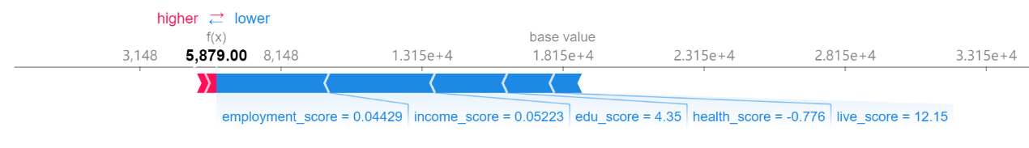

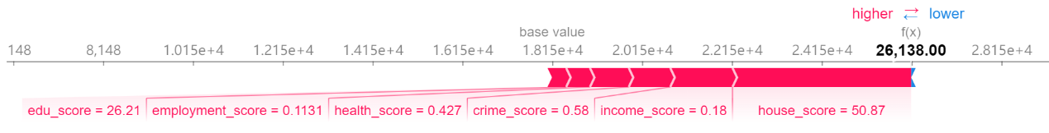

1. Scatter plot

Following SHAP scatter plots represent how the model output varies by feature value and whether the relationship between the target and the features are linear, monotonic, or more complex. Each dot is a single prediction (LSOA) from the dataset. The x-axis is the value of domain scores and the y-axis is the SHAP value for that feature.

The following dependence scatter plot gives us a clearer relationship between individual domain scores and their corresponding Shapley values. In general, they have the similar tendency: it's super-linear at the beginning, which means IMD rank increases significantly when domain scores are small. Then it becomes linear and finally tends to be sublinear. In addition, for points whose domain scores are lower than its average value, it corresponds to a negative Shapely value. It means the marginal effect this variable has on the predicted IMD rank is negative. While a higher-than-average domain score pushes the prediction higher. In addition, the vertical dispersion in the plot is only small when domain score is around average value, for other places, the same value for domain score can have a different impact on the model’s output for different LSOAs. Then, we would inspect each domain separately to see their difference.

For the first two plots, only the very beginning part (just above 0) has super-linearity. When income_score is larger than 0.3 and employment_score is larger than 0.2, it becomes sublinear and tend to e flat.

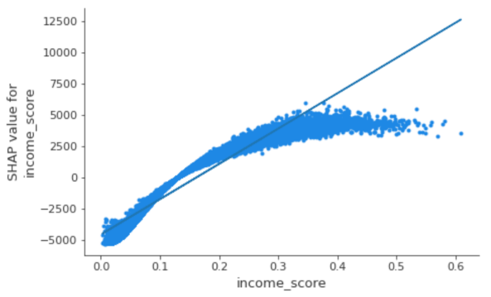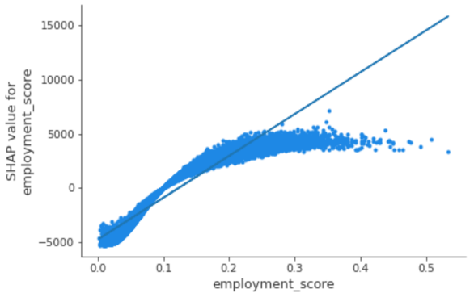

As for edu_score, house_score and live_score, their sub linear and super linear parts are not obvious and are more like a linear line, which means If they increase a certain value, its importance will grow proportionally. However, their vertical dispersion is large, so their prediction would not be stable and easier to be affected by other indicators.

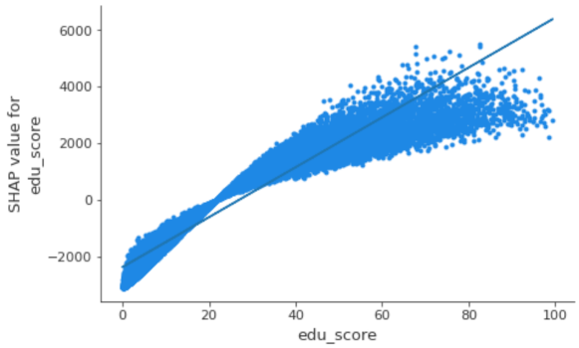

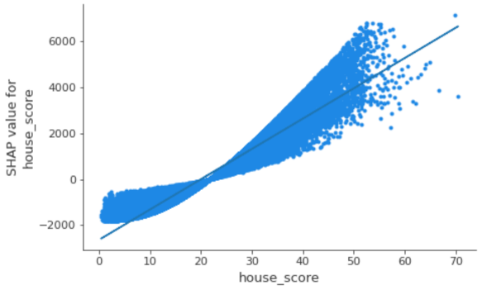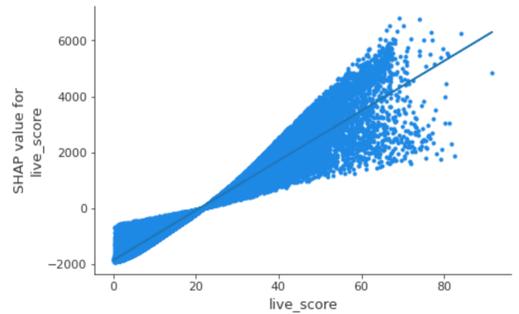

The super-linear part of health_score and crime_score is larger than other plots, which is more than half of the total length. Additionally, points in this part are more concentrated. When value of scores is after one, they turn to be more discrete and linear.

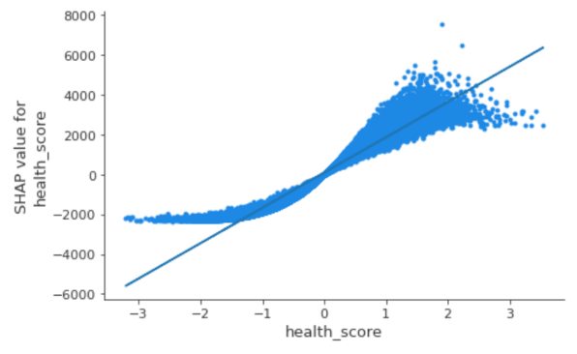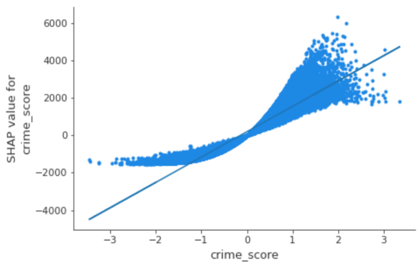

1. Summary plot

There are two kinds of summary plots. One is the typical bar chart of feature importance, which is gotten by taking the average absolute value of Shapley values of each feature and is actually the global importance I.

$$I_{j}=\sum_{i=1}^{n}{\left|ϕ_{j}\right|} (11)$$

From following plot, we can roughly see that the importance of Employment Score, Income Score are the highest and they are almost the same; the Education, Skills and Training Score's and the Health Deprivation and Disability Score's importance are the third and fourth one. The next two are the house_score and live_score, their importance are very similar, and the last one is the crime_score.

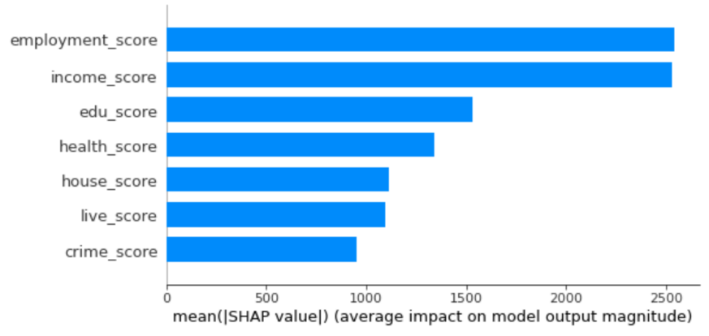

Figure 1 summary plot of the global importance

To get the specific importance of each feature, we use formula 11 to get the result and calculated their proportion (listed in table 3). Recall that the IMD combines information from the seven domains using the weights we have mentioned to produce an overall relative measure of deprivation. We also list these weights on the rightmost column to make comparison with the proportion of each domain’s importance as follows. Although there are some differences between the calculated proportion and the weight mentioned above: for the weight derived from importance, health_score is nearly 1.5% lower than the official weight; the live_score are house_score domains have about 0.7% difference with the official one; Others are slightly higher than official weight and the difference is within 0.5%, the overall structure are similar.

Table 3 average importance of each feature

|  |  |  |  |
| --- | --- | --- | --- |
| **feature** | **importance** | proportion | Official Weight |
| employment_score | 2542.109 | 0.228 | 22.5% |
| income_score | 2532.332 | 0.229 | 22.5% |
| edu_score | 1532.545 | 0.138 | 13.5% |
| health_score | 1342.020 | 0.121 | 13.5% |
| live_score | 1110.486 | 0.086 | 9.3% |
| house_score | 1093.447 | 0.100 | 9.3% |
| crime_score | 954.190 | 0.098 | 9.3% |

For the second kind of summary plot, the row of it results from projecting the points of a SHAP scatter plot onto the y-axis, then recoloring by the feature itself. This plot has loaded information and the biggest difference of this plot and the regular variable importance plot is that the color attribute allows us match how changes in the value of a feature effect the change in IMD rank and it also indicates the relationships of the predictors with the target variable.

As the variables are ranked by the feature importance in descending order, their sequence is the same as the figure 1. Besides, it’s interesting to get from figure 2 that the range of effects over the dataset in all domains behave similar. The effect of a high feature value is associated with a higher and positive prediction and when the feature values are low, they tend to contribute a negative effect to the final IMD score. Additionally, when feature values are low, they are more gathered especially for the last three domains, which also indicates that the change of the value for these features will not obviously influence the Shapley value. This can also be verified by the above scatter plot: when domain scores are below their average value, points are more gathered and the slope is relatively small. Similar phenomenon could be found for the first two domains when feature values are high.

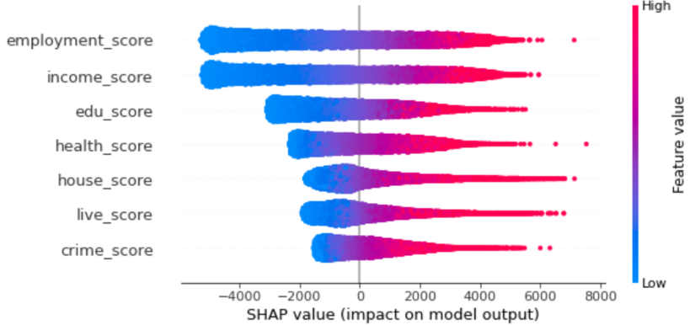

Figure 2 Summary plot contains more information

#### Clustering analysis

##### Clustering analysis for Shapley value

We have realized the existence of the variation for Shapley value in seven domains by the example of certain areas shown in force plot and non-linear pattern in scatter plot. However, it’s still unclear about how varied between 32844 areas. A good way is to divide the whole LSOAs into several part by clustering and use the average Shapley value of each domain to represent each part’ s circumstance.

K-Means Algorithm is used here to cluster the Shapley value for seven domains of LSOAs. Firstly, we need to find a suitable K. Elbow Criterion and Silhouette Coefficient is commonly used to evaluate K-Means clustering and choose K. These two indicators are plotted as follows where x axis is k and y axis are the value of two indicators. For the left plot, it seems that after K = 4, the line lean to be linear. For the right one, K = 4 is also acceptable although K = 2 is the best one. Combining these two figures, we decide that the K for Shapley value clustering is 4 As we might put more weight on the result of SSE.

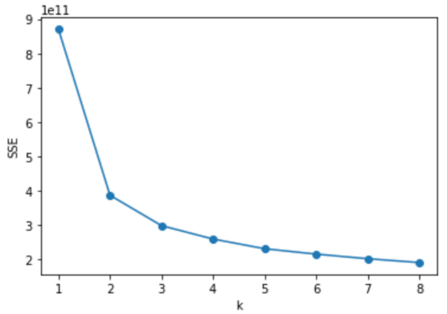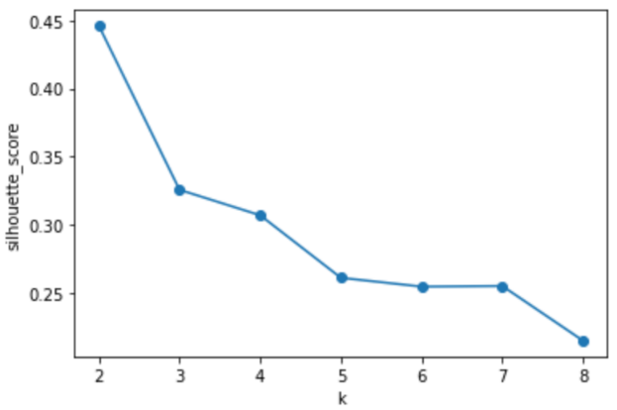

Then, we project our clustering result to the map in figure n. Most of the area in England are purple which is the cluster 1. Cluster 2 takes second, which is the areas in red and they seem to be radially distributed about the London. The concentrations of the areas in yellow (cluster 0) are located in the midland and the northeast. For LSOAs in the last cluster, it mainly disperses between the yellow areas. Next, let’s observe London alone. Surprisingly, the proportion of cluster 1 becomes the lowest and cluster 0 turns to be the highest. Red areas are prone to spread near the London border. What’s more, areas for blue are still randomly scattered in yellow areas in London.

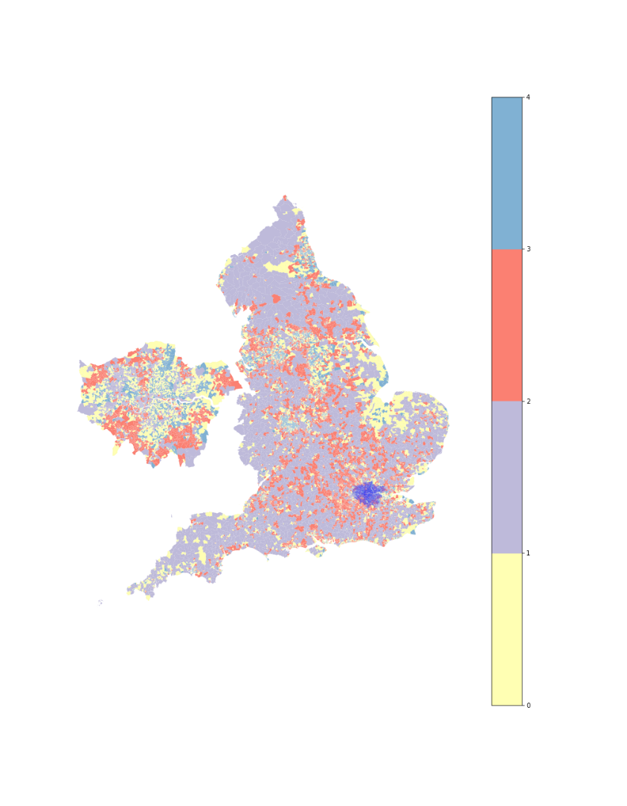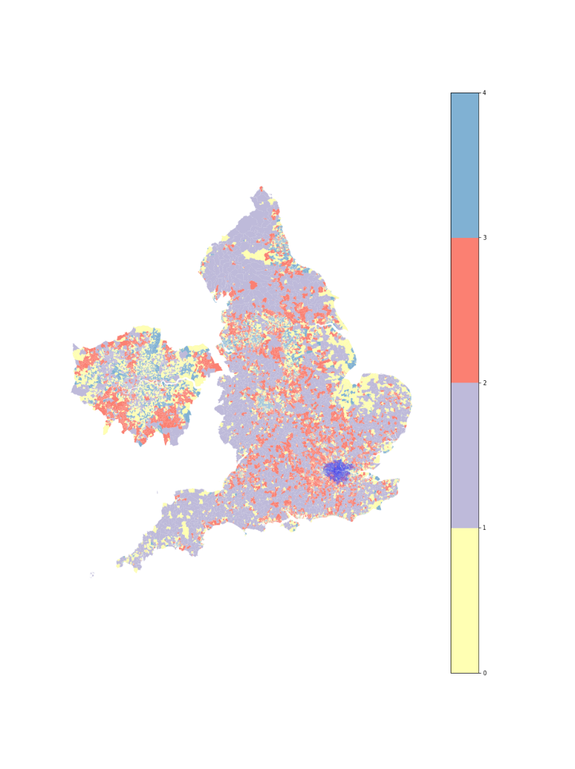

After knowing how each cluster distributed, we will see what is the composition of every cluster. Following table contains the cluster centers for seven domains in four clusters. If a domain’s Shapley value is positive, it would have positive contribution to the rank of IMD, which means the overall deprivation level of these area will also be higher. In cluster 2, all the Shapley value of domains’ center is negative, while for cluster 3, all of them are positive. Furthermore, except the Shapley value for House Domain and live Domain, other domains are negative in cluster 1, and the domains in the first three columns are also negative in cluster 0. When adding up all the Shapley value in seven domains, we can get the overall influence (if we add the total Shapley value with the base value, we can get the average rank of these areas). Thus, from the total Shapley value in table n, areas in cluster 3 are the most deprived and areas in cluster 2 is the least deprived among 4 clusters. 横向比较

|  |  |  |  |  |  |  |  |  |
| --- | --- | --- | --- | --- | --- | --- | --- | --- |
| cluster | income_ SHAP | employment_SHAP | edu_  SHAP | health_ SHAP | crime_  SHAP | house_ SHAP | live_  SHAP | total_  SHAP |
| 0 | -467 | -457 | -190 | 368 | 438 | 46 | 228 | -34 |
| 1 | -2519 | -2926 | -1559 | -1079 | -189 | 2531 | 1731 | -4009 |
| 2 | -3890 | -3804 | -2019 | -1278 | -621 | -371 | -842 | -12826 |
| 3 | 2593 | 2623 | 1462 | 1820 | 1015 | 101 | 217 | 9831 |

##### 

For better comparison, heat plot is created from the data in above table, so next, let’s compare each domain’s contribution in the same cluster. Although the contribution in all domains is the lowest in cluster two, the house domain still needs to be focused as it’s the highest one in this cluster two. It’s also the highest domain for cluster 1, besides, the live domain’s Shapley value is also large. Thus, these two domains are the main reason for the deprivation of cluster 1. The color in cluster 0 did not vary a lot. It means that the contribution for the 7 domain is relatively even than other clusters and maybe health and crime domain need to be paid more attention in this domain. The last cluster is the most deprived one, furthermore, the color of income and employment domain is dull-red. Therefore, to solve the overall deprivation of cluster 3, settle the problem from income and employment is crucial.

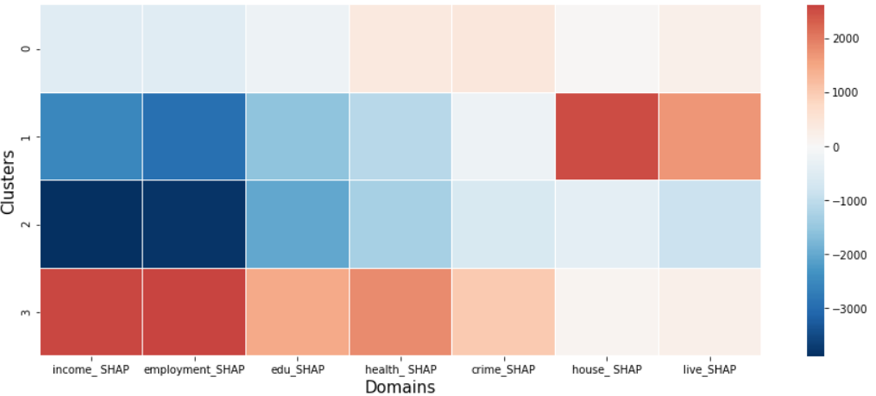

##### Clustering analysis for Score

Instead of using K-mean clustering method on the seven domain scores directly, we standardized the data (so that the mean is their center and component wise scale to unit variance) to eliminate the influence on the judgment of distance caused by the difference in dimension and order of magnitude. For the selection of K, the “elbow point” also happens when k equals to 4. The silhouette coefficient is the largest when k = 2, but is higher in k = 4 than in k = 3. We choose K=4 as our final answer.

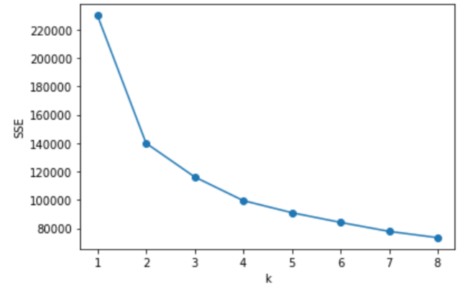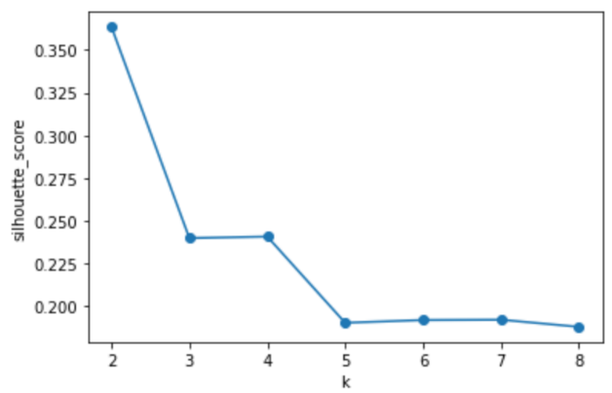

The majority land of the map is red (cluster 2), which pervades all around the England. Cluster 3 (blue area) and cluster 1 (purple) are the second and the third largest cluster in acreage on this map, and areas in yellow which represents cluster 0 is the smallest. The distribution of these four clusters in sequence is likely to corresponds to the cluster 1,2,0 and 3 on above map. Take a look at London alone. The proportional relationship of the four clusters is similar to the whole England. Cluster 1 and 3 gather around the boundary of London. Other areas are almost all belong to Cluster 2, as areas for cluster 0 are rare and scatter randomly in London.

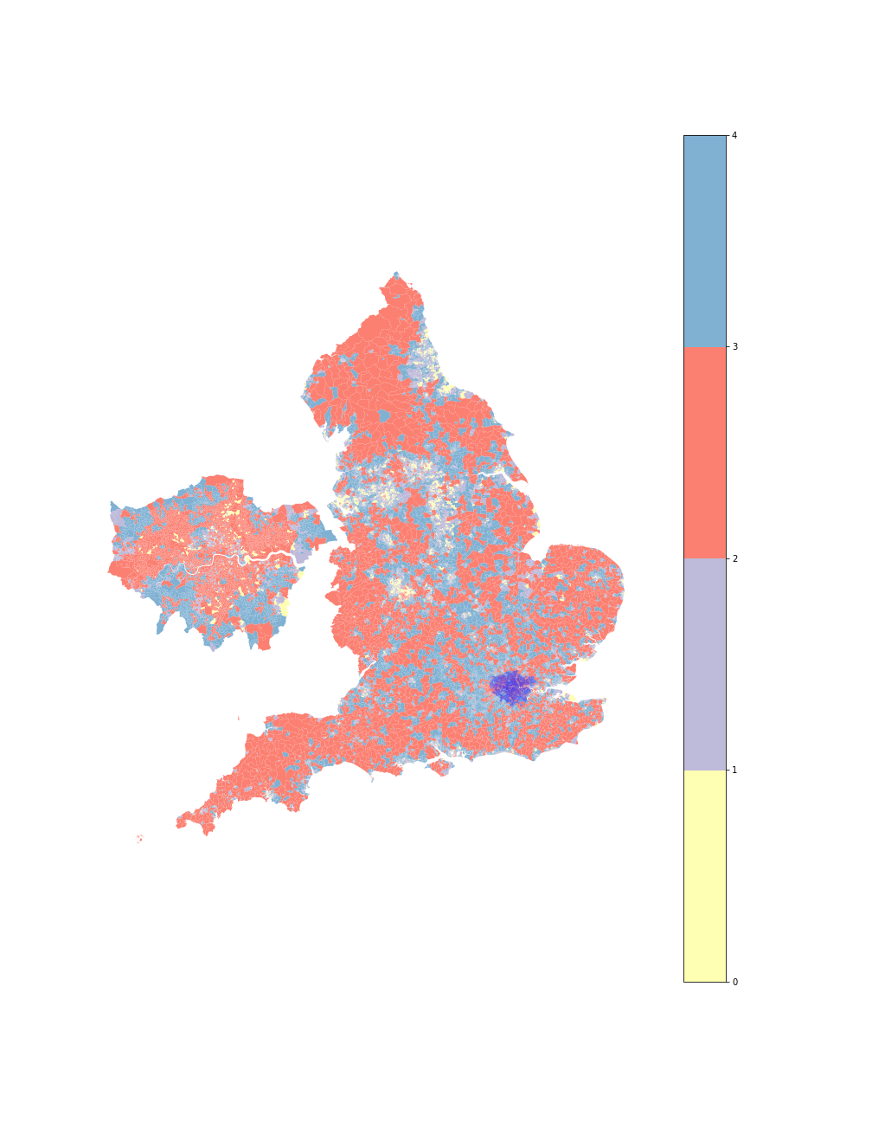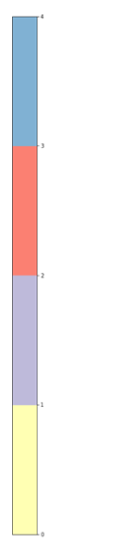

The cluster centers of scores are transformed to follow a standard distribution. Thus, it’s not necessary to list their number in a table and we just use these data to draw the heat plot directly. In cluster 1, six domains’ centers are positive, the only negative one is House Domain. It’s the same for cluster 0 but all the scores are higher (for domain scores in the first five columns, they are even the highest among 4 clusters). Moreover, the color of income, employment and edu are all dark red while in its corresponding cluster for SHAP, only the first two are of the similar color. It’s because the weight for income and employment is higher than edu. In contrary with cluster 0, cluster 3 has the smallest values for all the domains except the House Domain and all of them are negative. Cluster 2 has the highest value in House Domain and other domain are all to the third highest deprivation scores.

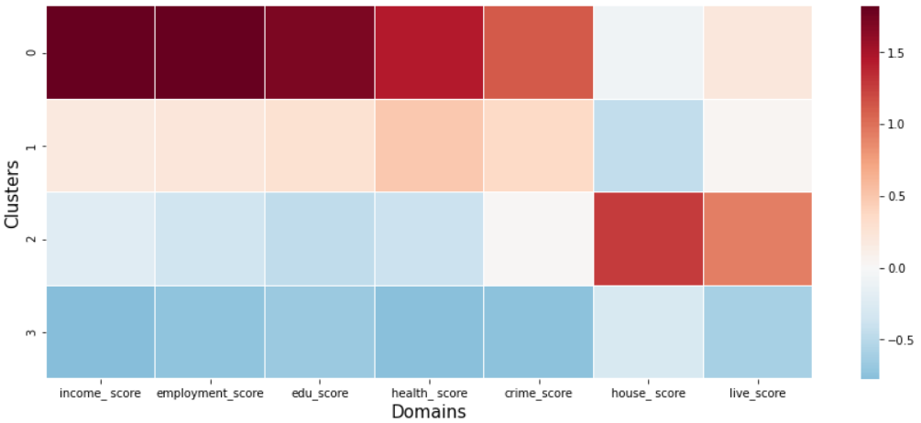

##### Comparison

To better compare the clustering result between two datasets. We scaled their clustering centers to range 0 and 1 and visualize the result using the radar plot. Moreover, the IMD Decile (where 1 is most deprived 10% of LSOAs) are also plotted. The first one is the radar plot for Shapley value, the second one is for scores and the last one is for decile. It seems that except live and house domains, other domains’ value for one cluster has the same rank. For example, the cluster 1 in figure n, cluster 2 in figure n and cluster 9 in figure n has the smallest value in all 5 domains. Besides, we deduced from above map that cluster 1,2,0,3 in map 1 corresponds to cluster 2,3,1,0 in map 2. This can also be verified from first two radar plots as they have similar data structure. As for the deprived level of these clusters, we already know from table n that the most deprived to the least deprived SHAP cluster are cluster 3, 0, 1 and 2 based on their contribution to overall IMD. Thus, we infer that the highest to the lowest score clusters are: 0,1,2 and 3 with respect to the deprivation level. Additionally, we find that the overall most deprived area according to IMD has a relatively low score in house domain.

Compared with the horizontal comparison (based on clusters) in Table N and figure n, we focus on the vertical comparison (based on domains) here as it’s more suitable to compare the relative value of domain when all the domain’s Shapley value is scaled to a same range. When observing the relative value of different clusters in the same domain in the left one, although the house domain is of the highest Shapley value, the health domain’s contribution is close to that of cluster one. Thus, in cluster two, health domain might still need to be focused. On the contrary, health domain is not an issue for cluster one in contrast with cluster two. The deprivation of cluster one mainly from live and house domain. Moreover, their relative value for live domain is more than double the second largest one and for house domain, it’s five times as much as its second largest one. The relative value is almost the same for cluster 0 and cluster 3 in live domain and the house domain, and in other domains, the relative value for cluster 3 is twice as much as the cluster 0.

In the figure n, as the domain scores are also scaled individually, therefore we can eliminate the effect of official weight and compare the relative value in the same domain for two figures. The cluster 3 is no longer the smallest in all domains, its house domain is higher than the cluster 1. For other domains in cluster 1, their relative values are farther away from cluster 0 than the relative distance between cluster 0 and cluster 3 for SHAP. In addition, the health domain in cluster 2 is not the closest to cluster 3. In the case, although we can establish a one-to-one correspondence between SHAP clustering result and score one, their difference within clusters still exists.

Overall, from following three plots, we know that the contribution of seven domains have different structure in four clusters and it provides the answer to our research question that there are variations of the contributions of seven deprivation domain scores to the Index of Multiple Deprivation (IMD) across LSOAs.

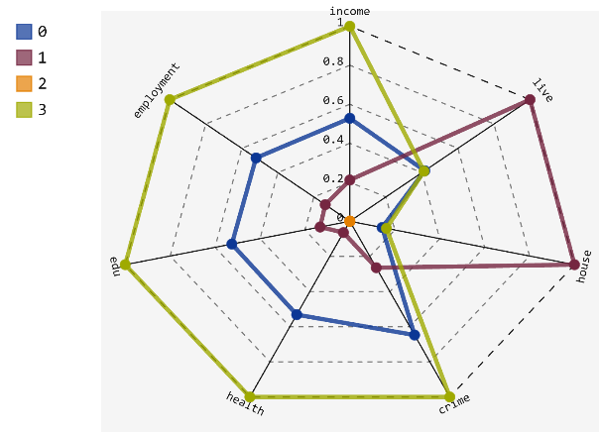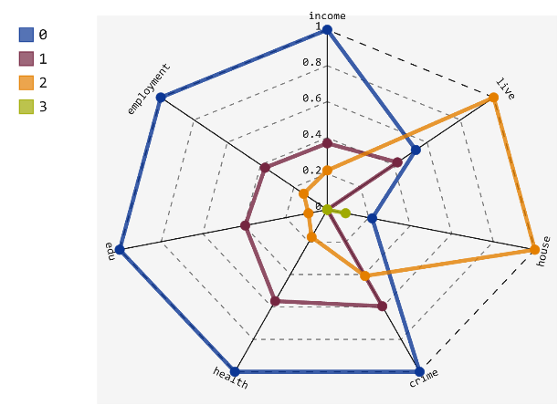

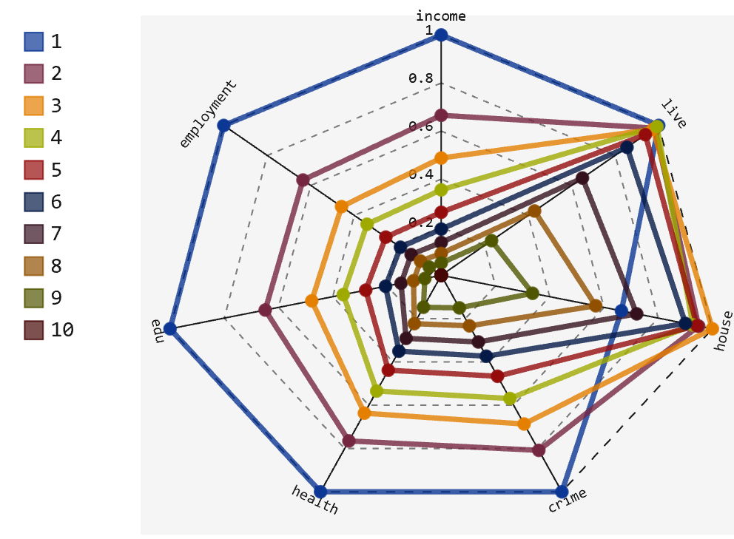

To confirm the deprivation rank of the four clusters. We compare them to the following map which depicts decile of LSOAs where 1 is most deprived and 10 is least deprived. We can roughly divide the color into crimson, red, pale red, Cambridge blue, blue and mazarine. From the perspective of IMD, the relatively most deprived areas which is colored dark red are concentrated in the middle eastern and northeast seaboard, and also scattered in region of north central and northwest-central in England. The proportion of these areas are higher in London and they disperse mainly in the middle (especially central north and central east) of London. Recall the map get by performing clustering for Shapley values, it seems above areas corresponds to the areas for cluster 3. Similarly, the navy-blue areas in decile map corresponds to cluster 2. On the whole, the map for SHAP clustering in London has a comparatively even composition, which means, each cluster correspond to a similar number of deciles. On the contrary, the clustering result for domain scores is mainly composed for two colors, red and blue, especially for London.

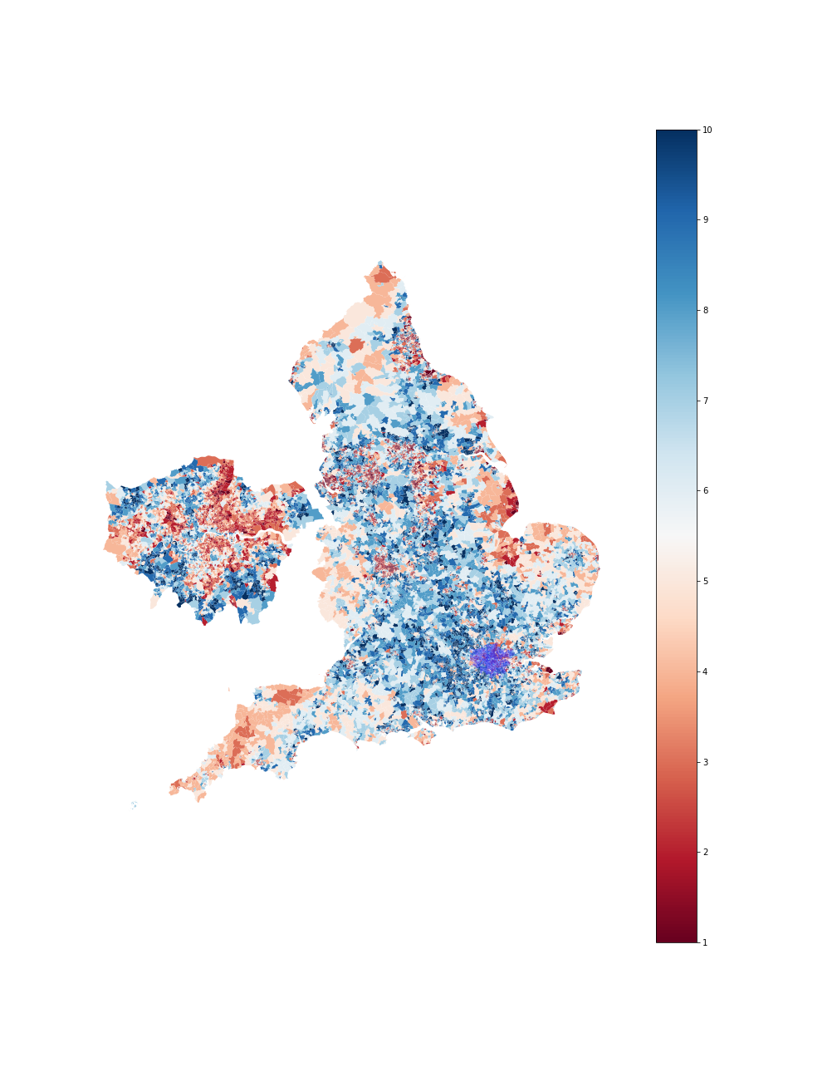

After comparing the three maps more meticulously, we listed a table to make things clear. Clusters or the colors in different map that are suspected to be relevant are put in one column and these columns are arranged according to their corresponding clusters’ degree of deprivation. There are 4 rows and 4 columns of the content. The first row represents the clusters and their corresponding colors for SHAP from the most deprived one to the least deprived and its next row is the corresponding decile in map n. Similarly, the third and the fourth rows shows the cluster and corresponding deciles for score.

Just as we have mentioned that there are mainly two colors in the clustering result for domain, cluster 2 and 3 for score covers a wide range of decile, from 2 to 10. Then, it comes to a question: Why cluster 0 is separated to be an individual cluster based on the fact that the corresponding decile for cluster 0 is included in cluster 2? If we turn back to the radar plots. We may get the answer: cluster 2 has the highest score for live and house domains, and their difference with the same domains for cluster 2 is larger than the difference for other five domains. Thus, despite the weight for live and house domain is relatively small, their overall IMD is similar and we overturn the suspect that cluster 1 is more deprived than cluster 2 with respect to score. We can only say that the data whose structure belongs to cluster 1 are less than that of cluster 2, and that’s why the areas for cluster 1 is small. Moreover, it reveals the shortcoming of IMD which is we cannot use the same strategy for the area in the same decile of deprivation, as they may be deprived in different domains. That’s also the reason why the corresponding decile for cluster 0 in SHAP partially intersects with cluster 3 and cluster 1.

|  |  |  |  |  |
| --- | --- | --- | --- | --- |
| Most deprived $→$… $→$ least deprived | | | | |
| shap | 3(blue) | 0 (yellow) | 1(purple) | 2(red) |
| Shap-decile | Deep red 1-2 | red 2-4 | light red and light blue 4-7 | ultramarine 8-10 |
| score | 0(yellow) | 1(purple) | 2(red) | 3(blue) |
| Score-decile | Dark red 1 | Red and Light red (3-5) | Most red and light blue (2-7) | Most Blue 7-10 |

## Discussion

From the randomly selected example of the force plot, we find that the contribution of 7 domains vary a lot in these areas. They can have the positive or the negative effect in different areas. Their absolute contribution can also be the largest in one area but be the smallest in another area. Besides, if the contribution in LSOAs is of the same weight for seven domains, the scatter plot should be like a linear line. However, most of them behave from the super linear at the beginning to the sub linear at last, which means when the domain scores are below the average, the increase of score’s value will speed up the growth of Shapley value, while when the score is large, the increment of score will not significantly improve its contribution to IMD. Moreover, for lower-than-average points, they are more concentrated but when the scores are high, the vertical dispersion of the scatter plot are large. This might result from non-linear interaction effects in the model between different domains. Just as Briggs et al. (2008) claims that it is hard to eliminate the influence from other domains because these domain are not independent with each other.

From above exploration, we have confirmed the bias of the seven domains’ contribution to the overall IMD in various areas. Then, we do clustering analysis to roughly divide them so that we can see how disparate they are. We can explicitly see that the contribution of seven domains vary a lot not only in the magnitude of the Shapley value but the structure of the data for 4 clusters. Thus, different areas should have different measurements.

Firstly, we will focus on the cluster that covers most areas, which is cluster1, as it could reflect the overall situation of England and would help to explain certain deprivation reasons for areas in other clusters. It is obvious that the Barriers to Housing and Services Domain is the main reason for the deprivation for cluster 1, which means housing affordability is likely to be one of the most severe problem in England with respect to obstacle to housing. Braakmann and McDonald (2020) claimed that the subsidy for it comprised more than 3% of UK government spending and become the second largest expenditure in the aspect of welfare (only less than the state pension) in 2011/2012. Besides, the housing benefit could cover up to 100% for the rent of a tenant who has low income after means testing. So why Barriers to Housing is still exists and has huge impact? Actually, the subsidy may raise the house prices as it enables recipients to rent houses with more space and refined decoration that they could not afford without the allowance and it would increase the pressure of other tenant especially for those who is not entitled to welfare but still in a straitened economic condition. Thus, constrains should be set on the property of the house that recipients could rent. Homelessness is also an important issue in the composition of housing problem. As for those unsheltered homeless adults, although government has provided city shelter, they prefer staying on the street rather than staying in crowded shelters mainly because of the threats of theft and physical harm. They also face barriers when applying independent housing and other services, like the difficulty in accessing necessary documents, frustration of long waiting process, bureaucratic obstacles and uncertainty of the result (Wusinich *et al.*, 2019). In this case, a safe and smaller haven which could give them more privacy is an ideal transitional place before they get temporary housing. In addition, service coordinators could be hired to give them individual guidance and after experiencing the bureaucratic inefficiencies and other problems, coordinators could give feedback and specific suggestions to help modify the inflexible and restrictive policy. However, just as Wusinich *et al.*, (2019) said :” Creating more affordable housing is the only viable way of ending homelessness”. In the aspect of barriers to services, geographical barrier to some peripheral support facilities like schools, post offices, supermarkets and GP surgery is the main problem. The most vulnerable group to this issue is the old tenants who are over 70 years old and at the same time have chronic health problems and decrements in cognitive and physical functioning (Golant, 2003). Lawton (1969) early realizes the problem of unmet supportive service needs for elderly residents and presses for the solution of it. For these frail residents, the financial firewall between the service delivery and the “bricks and mortar” issues should be broken down. Housing programs occupied exclusively by those seniors that integrate the housing and supportive service would be an appropriate alternative.

Areas in cluster one also suffer the living environment deprivation. Deas et al. (2003) doubts the effectiveness of IMD as some of the indicators which constitute different domains are highly correlated or even double counted across more than one domain. Considering the sub-domain of living environment deprivation, one is indoors living environment and the other is outdoors living environment. It is probable that areas suffer severe housing deprivation also face poor indoor housing condition. Thus, housing project mentioned above should also consider the indoor living environment building. For the outdoor one, its major contributors are from air quality and traffic accidents (involving injury to pedestrians and cyclists). According to a study conducted by Hansell *et al.* (2016) which lasts for 38 years and covers more than 370 thousand individuals, exposure to air pollution may have long-lasting impacts on mortality that persist decades. As the government has been promoting the transition to cleaner energy, the particulate concentrations of England show a declining trend. Jones *et al.* (2008) give us some hint on the traffic accident through their road traffic crash analysis. They found that many risk factors are speed-related and that’s why nearly every country has speed limits in buildings or crowded areas. Besides, reducing traffic volume is a potent way but it’s not realistic in the near future.

All the domains contribute negatively to the overall IMD in cluster 2, and it seems the relatively outstanding domain is the Barriers to Housing and Services Domain. However, just as we mentioned, most of areas in England experience a high level of deprivation in this aspect. It should be good by comparison. Since the income status in cluster 2 is the best, they could build more affordable house and provide better infrastructure and service. On the contrary, the situation in cluster 3 is difficult and all the domain have a positive Shapley value. It is likely that areas there are rural areas, as it’s deprived in all domains especially in income and employment domain but its deprivation level in housing domain is relatively small (because of the fewer population and lower rental and house prices). Graham, Glaister and Anderson (2005) claimed a positive relation between pedestrian casualties and deprivation across England. This can be explained that deprived rural areas may exist hazardous driving environment and cultures of dangerous driving behavior from the geographical distribution of road traffic crash analysis conducted by Haynes et al. (2005). Poor outdoor living environment caused by it could be weaken by intervention. For example, government there can adopt publicity-based measures or increase the level of enforcement. Air is moving, so the level of air pollution would not change significantly in nearby rural and urban areas. Nevertheless, there are differentials in exposure to the poor air quality. Milojevic et al. (2017) indicates that although there is modest difference in air pollution across UK, “pollution related relative risks are applied to substantial differences in the underlying mortality rates”. Thus, the overall improvement of air quality would benefit more on deprived rural areas and help shrink socioeconomic disparities in health. For those who are already in bad health or disability, public health research should pay attention to reduce discrimination by developing programs and policy. As the disability- based discrimination is incline to increase the odds of psychological distress and be a determinant of the poorer health outcomes especially for younger children, and low-income or unemployed people. (Krnjacki *et al.*, 2018). What’s worse, people who have perceived the discrimination lean to get poorer economic and social outcomes. Education is also a big deal in those suspected rural areas. Rafique and Khawaja (2020) studied the association between education profile and income in Pakistan. They discovered that the failure to raise 50% to at least primary education level from the uneducated population bring a potential income loss of PKR 251 billion. Moreover, they highlighted the importance not only in the development of individuals, but to the aggregate level development. Therefore, measures should be taken for all possible stakeholders. The research of Köthemann (2020) might give them an idea and he declared that the promotion of preschool participant can buffer the unfavorable social background from the educational deprivation. In addition, the skill training for adults is also a vital part of education . Hyde and Stapleton (2017) advices the public support such as technical training and financial support could also go to the older workers who do not reach the retirement age but feel strenuous in keeping up the work (because they have health problems and have difficult in adopting to new skills) to keep them in the labor force instead of all flocked to those who has stopped working. This measure can also prevent work disincentives and thus reduce the unemployment to some extent. Rafique and Khawaja (2020) remind that necessary physical capital and infrastructure should be provided to consume those educated and skilled human resource, otherwise they would not become the incentives, but the burden for the government. It is also crucial to solving unemployment. For the crime, Vollaard and van Ours (2011) proved that large scale of government intervention in executing built-in security regulation can better decrease the crime (especially can lower the burglary risk) than trying to improve the precautionary consciousness through subsidies on security or public campaign. security pacts are also effective in lowering predatory crimes like robberies and thefts (Calaresu and Triventi, 2019). Cluster 3 also faces relative severe crime deprivation and at the same time deprived in live environment and health domain. Harrison, Gemmell and Heller (2007) said that feeling unsafe is the potential largest barrier to physical activity on population levels. Thus, reducing crime and solve the problem in outdoor living environment can improve the perceived feeling of safety and therefore promote physical activity and increase the overall health status there.

## Conclusion and Limitation

IMD is frequently used to quantify geographic deprivation, though it has many limitations. The most important one is that they are the combination of multiple sub-indexes, which may face the risks we described previously. The subjectivity of the settings of the calculation process and the intrinsic flaw of the data may cause bias of the final IMD. In addition, it is difficult to compare the IMD through many aspects. People subconsciously assume that each domain contributes the same percentage in different places because the weight of each domain to form the IMD is fixed. However, our study found that the contributions of seven deprivation domain scores to the IMDs in England varies in LSOAs. It is clearer after we do the clustering and divide the similar small areas into 4 clusters. Most of the wards is deprived in housing and service domain and live environment domain. To cope with it, it is urgent to build more affordable housing with suitable living environment. In addition, the integration of the housing and services programs is a good way for elderly people who are in bad health. As for the deprived rural areas, almost all domains, except for the House Domain, are very serious. The basic idea to improve the situation in these areas is to develop the economy. And as a cycle, in order to develop the economy, we need to improve the other domains, especially the Education Domain and the Unemployment Domain

Limitation

1.  When constructing the Shapley Value Method, we use the average values as the references of each domain. Though this setting can speed up the computation, without using the random values, it may lead to the lack of accuracy.2. We classify the results into 4 clusters, which is subjective and empirical. In the future, we can try other clustering methods to auto-select the suitable cluster numbers.3. We only concentrate on the seven domains, haven’t explore more detail indicators. For example, we discuss how the income domain affects the deprivation, but we didn’t see more deeply into the sub-indicators, such as Adults and Children in Income Support Families Indicator, Adults and Children in Income-based Jobseeker's Allowance Families, and so on. If we can discuss it more detailly, we can get more accurate results.

## Reference

*A New Commitment to Neighbourhood Renewal*. (2001). London. Available at: http://www.bris.ac.uk/poverty/downloads/keyofficialdocuments/Neighbourhood Renewal National Strategy Report.pdf.

Aristondo, O. and Onaindia, E. (2020). ‘On measuring the sources of changes in poverty using the Shapley method. An application to Europe’. *Fuzzy Sets and Systems*. Elsevier B.V., 383, pp. 80–91. doi: 10.1016/j.fss.2018.12.011.

Bossel, H. (1999). *Indicators for sustainable development: theory, method, applications*. International Institute for Sustainable Development Winnipeg.

Braakmann, N. and McDonald, S. (2020). ‘Housing subsidies and property prices: Evidence from England’. *Regional Science and Urban Economics*, 80. doi: 10.1016/j.regsciurbeco.2018.06.002.

Briggs, D., Abellan, J. J. and Fecht, D. (2008). ‘Environmental inequity in England: Small area associations between socio-economic status and environmental pollution’. *Social Science and Medicine*. Pergamon, 67 (10), pp. 1612–1629. doi: 10.1016/j.socscimed.2008.06.040.

Bull, A. C. and Jones, B. (2006). ‘Governance and social capital in urban regeneration: A comparison between Bristol and Naples’. *Urban Studies*, 43 (4), pp. 767–786. doi: 10.1080/00420980600597558.

Calaresu, M. and Triventi, M. (2019). ‘Governing by contract as a way to reduce crime? An impact evaluation of the large-scale policy of security pacts’, 52, pp. 255–279. doi: 10.1007/s11077-018-9337-1.

Chen, C. and Li, S. (2014). ‘Market transition and income inequality in urban China: Evidence from shapley value decomposition’. *Frontiers of Economics in China*, 9 (2), pp. 309–337. doi: 10.3868/s060-003-014-0016-9.

CHUN, Y., HU, C.-C. and YEH, C.-H. (2017). ‘A Strategic Implementation of the Shapley Value for the Nested Cost-Sharing Problem’. *Journal of Public Economic Theory*, 19 (1), pp. 219–233. doi: 10.1111/jpet.12190.

Clelland, D. and Hill, C. (2019). ‘Deprivation, policy and rurality: The limitations and applications of area-based deprivation indices in Scotland’. *Local Economy: The Journal of the Local Economy Policy Unit*, 34 (1), pp. 33–50. doi: 10.1177/0269094219827893.

DCLG. (2008). *Transforming places; changing lives: A framework for regeneration*. London.

Deas, I., Robson, B., Wong, C. and Bradford, M. (2003). ‘Measuring neighbourhood deprivation: A critique of the Index of Multiple Deprivation’. *Environment and Planning C: Government and Policy*, 21 (6), pp. 883–903. doi: 10.1068/c0240.

Dong, F., Yu, B., Pan, Y. and Hua, Y. (2020). ‘What contributes to the regional inequality of haze pollution in China? Evidence from quantile regression and Shapley value decomposition’. *Environmental Science and Pollution Research*. Environmental Science and Pollution Research, 27 (14), pp. 17093–17108. doi: 10.1007/s11356-020-07929-8.

Exeter, D. J., Zhao, J., Crengle, S., Lee, A. and Browne, M. (2017). ‘The New Zealand Indices of Multiple Deprivation (IMD): A new suite of indicators for social and health research in Aotearoa, New Zealand’. *Exeter, D. J., Zhao, J., Crengle, S., Lee, A. and Browne, M. (2017). ‘The New Zealand Indices of Multiple Deprivation (IMD): A new suite of indicators for social and health research in Aotearoa, New Zealand’. PLoS ONE, 12 (8), pp. 1–19. doi: 10.1371/journ*, 12 (8), pp. 1–19. doi: 10.1371/journal.pone.0181260.

Golant, S. M. (2003). ‘Political and organizational barriers to satisfying low-income U.S. Seniors’ need for affordable rental housing with supportive services’. *Journal of Aging and Social Policy*, 15 (4), pp. 21–48. doi: 10.1300/J031v15n04_02.

Graham, D., Glaister, S. and Anderson, R. (2005). ‘The effects of area deprivation on the incidence of child and adult pedestrian casualties in England’. *Accident Analysis and Prevention*, 37, pp. 125–135. doi: 10.1016/j.aap.2004.07.002.

Gul, F. (1989). ‘Bargaining foundations of Shapley value’. *Econometrica:* JSTOR, pp. 81–95.

Hansell, A., Ghosh, R. E., Blangiardo, M., Perkins, C., Vienneau, D., Goffe, K., Briggs, D. and Gulliver, J. (2016). ‘Historic air pollution exposure and Long-term mortality risks in England and Wales: Prospective longitudinal cohort study’. *Thorax*, 71 (4), pp. 330–338. doi: 10.1136/thoraxjnl-2015-207111.

Harrison, R. A., Gemmell, I. and Heller, R. F. (2007). ‘The population effect of crime and neighbourhood on physical activity: an analysis of 15 461 adults’. *Journal of Epidemiology & Community Health*. BMJ Publishing Group Ltd, 61 (1), pp. 34–39. doi: 10.1136/JECH.2006.048389.

Hyde, J. S. and Stapleton, D. C. (2017). ‘Using the Health and Retirement Study for Disability Policy Research: A Review’. *Forum for Health Economics and Policy*, 20 (2), pp. 1–12. doi: 10.1515/fhep-2017-0002.

Jones, A. P., Haynes, R., Kennedy, V., Harvey, I. M., Jewell, T. and Lea, D. (2008). ‘Geographical variations in mortality and morbidity from road traffic accidents in England and Wales’. *Health & Place*, 14, pp. 519–535. doi: 10.1016/j.healthplace.2007.10.001.

Kintrea, K. (2007). ‘Policies and Programmes for Disadvantaged Neighbourhoods: Recent English Experience’. *Housing Studies*, 22 (2), pp. 261–282. doi: 10.1080/02673030601132920.

Köthemann, D. (2020). ‘How educational systems shape the relationship between social origin and educational : Deprivation cross-national analyses in the first years after finishing secondary school’. *Comparative Sociology*, 19 (2), pp. 279–303. doi: 10.1163/15691330-BJA10013.

Krnjacki, L., Priest, N., Aitken, Z., Emerson, E., Llewellyn, G., King, T. and Kavanagh, A. (2018). ‘Disability-based discrimination and health: findings from an Australian-based population study’. *Australian and New Zealand Journal of Public Health*, 42 (2), pp. 172–174. doi: 10.1111/1753-6405.12735.

Kuhn, H. W. (1997). *Classics in Game Theory*. Princeton University Press (Frontiers of Economic Research). Available at: https://books.google.co.uk/books?id=HyTpw6H5syUC.

Lawton, M. P. (1969). ‘Supportive Services in the Context of the Housing Environment’. *The Gerontologist*, 9 (1), pp. 15–19. doi: 10.1093/geront/9.1.15.

Li, T., Baležentis, T., Makutėnienė, D., Streimikiene, D. and Kriščiukaitienė, I. (2016). ‘Energy-related CO2 emission in European Union agriculture: Driving forces and possibilities for reduction’. *Applied Energy*, 180, pp. 682–694. doi: 10.1016/j.apenergy.2016.08.031.

Liang, Y., Niu, D., Zhou, W. and Fan, Y. (2018). ‘Decomposition Analysis of Carbon Emissions from Energy Consumption in Beijing-Tianjin-Hebei, China: A Weighted-Combination Model Based on Logarithmic Mean Divisia Index and Shapley Value’. *Sustainability*, 10 (7), p. 2535. doi: 10.3390/su10072535.

Lu, W., Chen, Y., Zhang, N. and Shi, Y. (2010). ‘Ticket pricing of urban rail transit based on Shapley value method’. *Proceedings - 2010 2nd IEEE International Conference on Information and Financial Engineering, ICIFE 2010*. IEEE, pp. 127–130. doi: 10.1109/ICIFE.2010.5609267.

Lundberg, S. M., Erion, G. G. and Lee, S.-I. (2018). ‘Consistent individualized feature attribution for tree ensembles’. *arXiv preprint arXiv:1802.03888*.

Lundberg, S. M. and Lee, S. I. (2017). ‘A unified approach to interpreting model predictions’. *Advances in Neural Information Processing Systems*, 2017-Decem (Section 2), pp. 4766–4775.

Macintyre, S., Macdonald, L. and Ellaway, A. (2008). ‘Do poorer people have poorer access to local resources and facilities? The distribution of local resources by area deprivation in Glasgow, Scotland’. *Social Science & Medicine*, 67 (6), pp. 900–914. doi: 10.1016/j.socscimed.2008.05.029.

Maier, W. (2017). ‘Indizes Multipler Deprivation zur Analyse regionaler Gesundheitsunterschiede in Deutschland’. *Bundesgesundheitsblatt - Gesundheitsforschung - Gesundheitsschutz*, 60 (12), pp. 1403–1412. doi: 10.1007/s00103-017-2646-2.

Ministry of Housing Communities and Local Government. (2019). ‘The English Indices of Deprivation 2019: Research report’, (September), pp. 1–86. Available at: https://www.gov.uk/government/publications/english-indices-of-deprivation-2019-technical-report%0Ahttps://www.gov.uk/government/publications/english-indices-of-deprivation-2019-technical-report%0Ahttps://assets.publishing.service.gov.uk/government/uploads.

Molnar, C. (2021). *5.9 Shapley Values | Interpretable Machine Learning*. Available at: https://christophm.github.io/interpretable-ml-book/shapley.html#general-idea (Accessed: 15 June 2021).

Noble, M., Wright, G., Smith, G. and Dibben, C. (2006). ‘Measuring Multiple Deprivation at the Small-Area Level’. *Environment and Planning A: Economy and Space*, 38 (1), pp. 169–185. doi: 10.1068/a37168.

OCSI. (2011). *Why the Indices of Deprivation are still important in the open data era*. *Oxford Consultants for Social Inclusion*. Available at: https://ocsi.uk/2011/03/24/why-the-imd-is-still-important-in-the-open-data-age/ (Accessed: 12 July 2021).

Pérez-Castrillo, D. and Wettstein, D. (2001). ‘Bidding for the surplus: a non-cooperative approach to the Shapley value’. *Journal of economic theory*. Elsevier, 100 (2), pp. 274–294.

Petrosjan, L. and Zaccour, G. (2003). ‘Time-consistent Shapley value allocation of pollution cost reduction’. *Journal of Economic Dynamics and Control*, 27 (3), pp. 381–398. doi: 10.1016/S0165-1889(01)00053-7.

Reddy, P. V., Shevkoplyas, E. and Zaccour, G. (2013). ‘Time-consistent Shapley value for games played over event trees’. *Automatica*, 49 (6), pp. 1521–1527. doi: 10.1016/j.automatica.2013.02.029.

Shapley, L. S. (1953). ‘"A Value for n% person Games. Contributions to the Theory of Games’. *Annals of Mathematics Studies*, 28 (2), pp. 307–317.

Siano, G., Gallo, M. and Glielmo, L. (2015). ‘A method for managing transportation requests and subdivision costs in shared mobility systems’. *VEHITS 2015 - Proceedings of the 1st International Conference on Vehicle Technology and Intelligent Transport Systems*, pp. 152–158. doi: 10.5220/0005459501520158.

Smith, M. and Alvarez, F. (2021). ‘Identifying mortality factors from Machine Learning using Shapley values – a case of COVID19’. *Expert Systems with Applications*, 176, p. 114832. doi: 10.1016/j.eswa.2021.114832.

*Transforming Places; Changing Lives: Taking Forward the Regeneration Framework*. (2009). London.

University of Oxford. (2000). *Response to the Formal Consultations on the Indices of Deprivation 2000*.

Vollaard, B. and van Ours, J. C. (2011). ‘Does Regulation of Built-in Security Reduce Crime? Evidence from a Natural Experiment’. *Economic Journal*, 121 (552), pp. 485–504. doi: 10.1111/j.1468-0297.2011.02429.x.

Watson, V., Dibben, C., Cox, M., Atherton, I., Sutton, M. and Ryan, M. (2019). ‘Testing the Expert Based Weights Used in the UK’s Index of Multiple Deprivation (IMD) Against Three Preference-Based Methods’. *Social Indicators Research*. Springer Netherlands, 144 (3), pp. 1055–1074. doi: 10.1007/s11205-018-02054-z.

Wen, L. and Hao, Y. (2020). ‘Factor decomposition and clustering analysis of CO2 emissions from China’s power industry based on Shapley value’. *Energy Sources, Part A: Recovery, Utilization and Environmental Effects*. Taylor & Francis, 00 (00), pp. 1–17. doi: 10.1080/15567036.2020.1776795.

Wusinich, C., Bond, L., Nathanson, A. and Padgett, D. K. (2019). ‘“If you’re gonna help me, help me”: Barriers to housing among unsheltered homeless adults’. *Evaluation and Program Planning*. Pergamon, 76, p. 101673. doi: 10.1016/J.EVALPROGPLAN.2019.101673.

Yan, Q., Wang, Y., Baležentis, T., Sun, Y. and Streimikiene, D. (2018). ‘Energy-Related CO2 Emission in China’s Provincial Thermal Electricity Generation: Driving Factors and Possibilities for Abatement’. *Energies*, 11 (5), p. 1096. doi: 10.3390/en11051096.

Yu, S., Wei, Y. M. and Wang, K. (2014). ‘Provincial allocation of carbon emission reduction targets in China: An approach based on improved fuzzy cluster and Shapley value decomposition’. *Energy Policy*. Elsevier, 66 (2014), pp. 630–644. doi: 10.1016/j.enpol.2013.11.025.

Zhang, Y. J., Wang, A. D. and Da, Y. Bin. (2014). ‘Regional allocation of carbon emission quotas in China: Evidence from the Shapley value method’. *Energy Policy*. Elsevier, 74 (C), pp. 454–464. doi: 10.1016/j.enpol.2014.08.006.

1. The rank in this article refers to rank that is get by ranking the scores in an ascending order unless we specify the rank is the domain rank from official website.